

**2022 Annual Conference**

**18-21October 2022**

Minutes of the meeting

The EU Pooling & Sharing Mountain Training Initiative (EU P&S MTI) 2022 Annual Conference took place from 18to 21 October 2022 at the Spanish Mountain Troops Headquarters (SPMTHQ) in Pamplona/Spain.

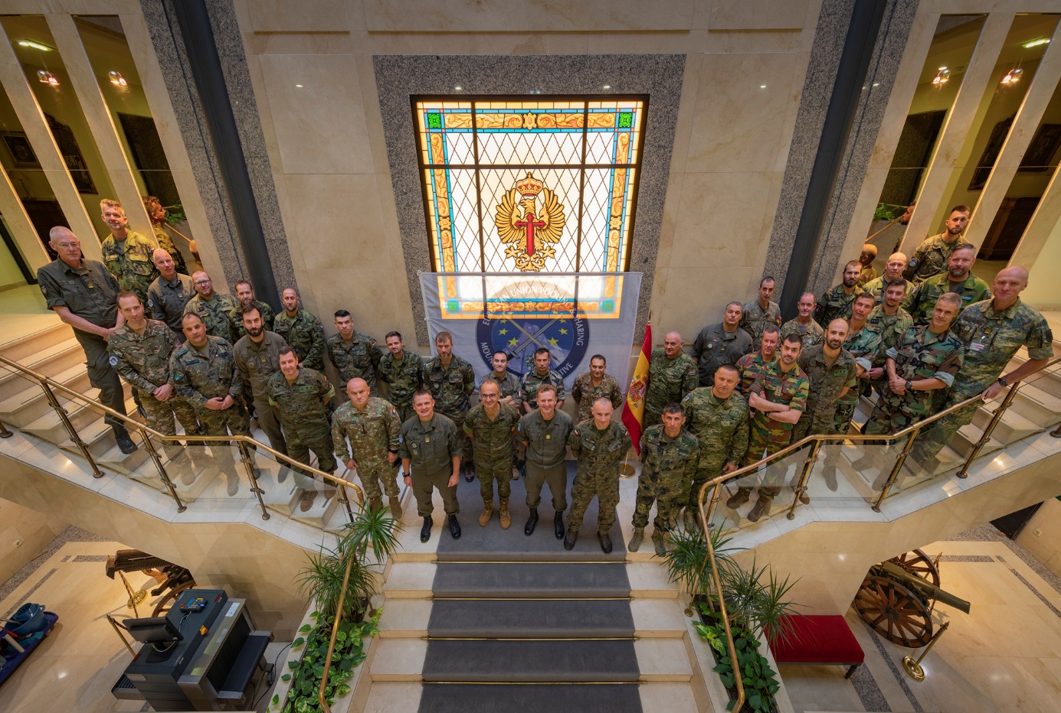

The conference was hosted by BG MARTINEZ LOZANO Francisco Germán, Commander Spanish Mountain Troops, and was conducted by the Austrian Armed Forces Training Coordination Division.

Representatives of the twelve participating nations (Austria, Belgium, Bulgaria, Croatia,   
Czech Republic, France, Germany, Netherlands, Poland, Slovenia, Spain and Sweden),   
the NATO MW COE as Permanent Guest and of the Initiative’s Guests, Italy and Romania, took part in the Conference.

List of Attendees see Annex A (***List of Attendees***)

**Summary of results and conclusions achieved as well as decisions taken during the 2022 Annual Conference**

**Syndicate Needs & Offers (N&O)**

Within the framework of N&O, positive approvals were obtained in the various subjects.

* In total 28 requests for MTAs in Austria could be confirmed to the MTI-participants for 2023.
* It was acknowledged that the MTI-Community has the need to support each other by sending instructors to international mountainous courses, to more effectively increase the number of qualified soldiers.

Details see Annex B (***Syndicate Work Needs & Offers***)

**Syndicate Capability Development**

During the Annual Conference the “Allocation Chart” in regard of new courses, changes of courses or course cancellations of all courses offered to/by MTI-Members has been evaluated. The aim at the end of the process was, to provide a database with all “Course Descriptions” of the courses, which are offered to/by the MTI-members. The nations came up with their presentations and the “Allocation Chart” was brought to an actual status.

Details see Annex B (***Syndicate Work Capability Development***)

**Syndicate Lessons Identified/Lessons Learned (LI/LL)**

***Mtn-Equipment Database***

A Mtn Equipment Database was finally agreed upon for all nations to further contribute by filling its own data. The results were presented to the PC and the former given task by the PC was reported accomplished pending nations’ contribution.

The Database comprises of

* General data of Mtn Equipment
* Table of Equipment (ToE) for Mtn Equipment up to platoon level
* POC-list related to procurement of Mtn Equipment
* outlook of nations’ procurements for the next 3-5 years

***Factsheet***

On basis of a Draft Factsheet, the representatives in the Syndicate decided about a useful content in it. The result was presented to the PC and the former given task by the PC was reported accomplished pending nations’ contribution until 15 December 2022.

***LI/LL-Contribution to preparation of upcoming Exercises***

Due to little LI obtained during latest exercises while showing vastly the same observations repeatedly the focus shall shift to a provision of an “observation list”. MTI-Participants’ exercise planners shall involve a LI/LL-Team and or staff personnel to support during the planning and conduct of an exercise if applicable.

Staff personnel from AUT shall and due to the correlation with BERGLÖWE 2025, staff personnel from DEU as well should support RHODOPE 2024.

Details see Annex B (***Syndicate Work LI/LL***)

**ALPINE DEFENSE 2024 (AD-24) - FTX/LFX Joint Fire Support – INVITEX to the MTI-community by AUT**

* All MTI-participants (participating nations) are invited to participate with JFST, aircrafts, 1 mortar platoon, observers, controllers and staff personnel.
* A first estimation of all nations’ participation is expected to be forwarded   
  **NLT 15 January 2023** to office MTI.

Details are available in the given presentation on the MTI-website. (20221019_04_AUT_AD-24_update.pptx)

**Sequence Minutes of the meeting**

Tuesday, 18 October 2022

**Ice Breaker**

1900-2200 hrs: The Host Nation Spain invited to an Ice Breaker at the new Spanish Mountain Troops Headquarters in Pamplona.

COL BOUDET, Deputy Commander of the Spanish Mountain Troops, opened the event with his welcoming speech.

Afterwards, the Head of the Austrian Armed Forces Training Coordination Division and Chairman of the Initiative, BG HOLZER, addressed all the heads of delegations, and they were invited to introduce their colleagues to the MTI-community. A special welcome was given to the French delegation, since France had just recently (22 September 2022) officially joined the MTI-family.

The excellently prepared Ice Breaker offered a worthy environment for a cooperative come together and so, after the Padre gave his blessings, the buffet was opened.

Wednesday, 19 October 2022

**Opening Ceremony**

0800-0845 hrs: The official host, BG MARTINEZ LOZANO Francisco Germán, Commander of the Spanish Mountain Troops welcomed the participants of the 8th Planning Committee Meeting (PCM) & 2022 Annual Conference in PAMPLONA, and wished all participants a successful conference.

The Chairman BG HOLZER thanked for the opening remarks, and reminded all the represented nations of the founding of the “Mountain Training Initiative,” and how it had all begun with the idea of “pooling and sharing” many years ago.

Followed by Acting Chairman, COL RITZ, with presenting the Schedule for the conference, CPT SERRANO (ESP) went on with his admin remarks and thereafter gave a briefing about the Spanish Mountain Troops Command.

(20221019_01_AUT_ESP_Introduction.pptx)

After a short break for a group photo, the Topic “Exercise Series” was presented to the plenum.

**Exercise Series**

0900-1030 hrs: The Acting Chairman informed that the topic would first be discussed in the plenum and then discussed in the PCM. Then he handed over to CPT DELENK (DEU) to present the BERGLÖWE.

(20221019_02_AUT_Exercise_Series.pptx)

CPT DELENK informed the community that the exact period of time the BERGLÖWE 2023 will be held was not determined yet, but it shall be forwarded in the following weeks. He did though remind that the BERGLÖWE 2025 would take place in the beginning of 2025, so that participants will have to cope with wintry conditions.

(20221019_03_DEU_Exercise_Series_Berglöwe.pptx)

Then COL ZHELEV (BGR) informed the auditorium that the RHODOPE 2023 had already been closed for further MTI participation, but that there still is a gap for bilateral agreements to participate. Referring to the RHODOPE 2024 (winter) COL ZHELEV expressed his need for assistants in creating suitable scenarios, documents and SOPs, and therefore invited all members to a RECCE in March 2023; further details would be available until the Initial Planning Conference (IPC).

Afterwards, LTC TEMMEL (AUT) presented the current planning status of FTX/LFX Joint Fire Support (JFS) ALPINE DEFENSE 2024 (AD-24) based on a presentation available on MTI-website. (20221019_04_AUT_AD-24_update.pptx)

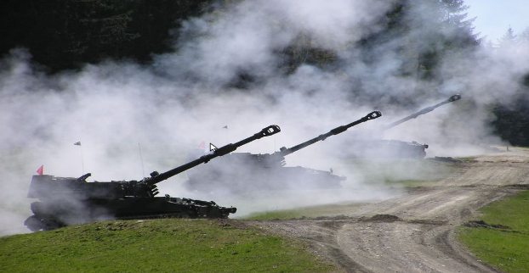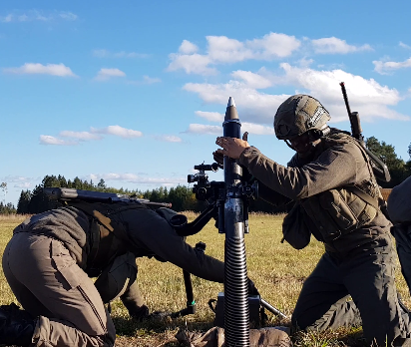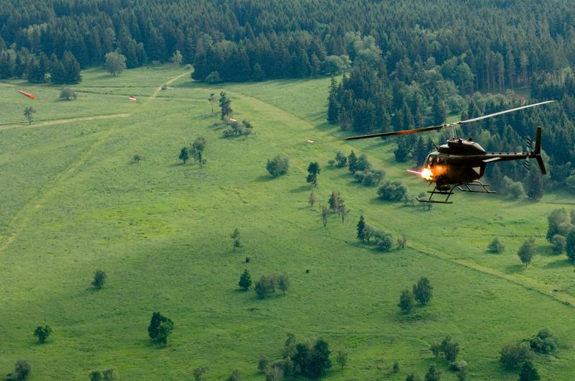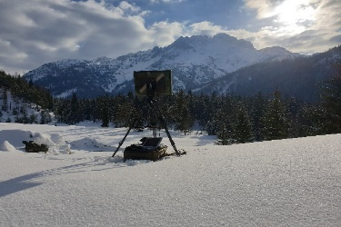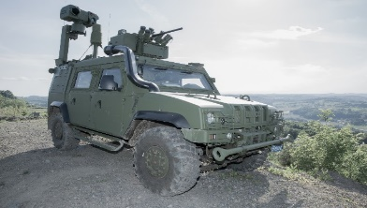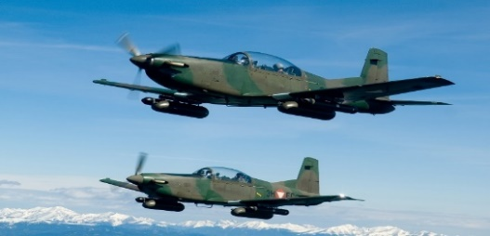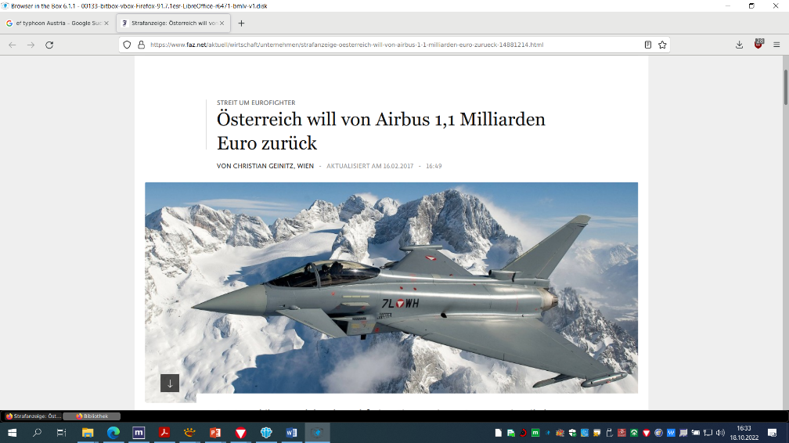

AD-24 is the third LFX JFS in a row after the AD-21 and AD-22 conducted in AUT.

While the AD-21 and AD-22 were national exercises open to JFST from MTI-participating nations the AD-24 will be an INVITEX with participation of JFST, Aircrafts (FW, RW) and   
1 mortar platoon as well as observers, controllers and staff personnel. This as well requires an Exercise Planning Process according to the Bi-SC Exercise Planning Directive. Details will follow with the invitation to the Exercise – dates for IPC, MPC and FCC are within the presentation.

The given presentation with details known as of now is meant to initiate nations to assess an estimation of participation until 15 January 2023. A formal invitation will follow NLT March 2023.

AUT as Lead Nation of MTI will forward these minutes via the Military Attachés with the request to spread this information not only to the MW-community but also to the national Joint Fire Support-community (Air force, Artillery).

The Acting Chairman then informed about the intention to make the exercise offer visible on the internet platform. He then interrupted the processing of this topic because it would be further processed in the PCM.

**Needs & Offers**

1030-1115 hrs: CPT RESCH (AUT) presented the needs and offers by going through the Database, followed by a brief presentation of the competition EDELWEISS RAID 23 by   
COL LEHNER (AUT).

(20221019_05_AUT_EDELWEISS RAID 23.pptx)

CPT RESCH invited all representatives in accordance with the database briefing given before to single sessions in order to assess commonly the results of each nation’s announced Needs. Main Topic was the nations’ needs to use MTAs in AUT.

**P&S MTI Website**

1200-1230 hrs: MAJ EIBINGER (AUT) presented the new P&S MTI Website (<https://www.mti.bmlv.gv.at>).

**Planning Committee Meeting and Syndicate Work**

1400-1600 hrs: The plenary divided into the Planning Committee (PC), the 2 Syndicates Capability Development (CapDev) and Lessons Identified/Lessons Learned (LI/LL) and bilateral talks with every nation’s representative were held concerning Needs & Offers.

Results PCM see Minutes of the 8th PCM (for MTI Participants only), Results Syndicate Work see Annex B (***Syndicate Results***).

**Site Survey**

1715-1915 hrs: After the working session, a Site Survey in the city of Pamplona took place.

Thursday, 20 October 2022

**Morning address**

0800-0845 hrs: The Morning address was given by the Acting Chairman followed by a presentation of the Italian Mountain Warfare Training System held by LTC PEZZINO (ITA).

(20221020_10_ITA_Italian Mountain Troops.pptx)

**Planning Committee Meeting and Syndicate Work**

0900-1300 and 1400-1600 hrs: The plenary again, like the day before, divided into the PC, the two (2) Syndicates Capability Development (CapDev) and Lessons Identified/Lessons Learned (LI/LL) and bilateral talks with every nation’s representative were proceeded concerning Needs & Offers.

Results PCM see Minutes of the 8th PCM (for MTI Participants only), Results Syndicate Work see Annex B (***Syndicate Results***).

**Final presentation of results and way ahead**

1630-1800 hrs: The Acting Chairman, COL RITZ, started with the results of the PCM.

He informed about the Annual Report 2020/21, which will be officially forwarded to Participants and Permanent Guests via the respective national Attaché. He notified about the tasks given to the syndicates and the topic “Further Development of the Initiative”.

He then presented the EU P&S MTI Program of Work 2023 and following:

* 2023 Expert Talks in Croatia (TBC) in April/May 2023
  + IPC RHODOPE 2024
* 9th PCM & 2023 Annual Conference in September/October 2023  
  in Austria
* Recce RHODOPE 2024 in March 2023 AUT, DEU (TBD),
* IPC ALPINE DEFENSE 2024 in May 2023
* BERGLÖWE 2023 3 weeks in October 2023
* MPC RHODOPE 2024 in September/October 2023
* MPC ALPINE DEFENSE 2024 4. Quarter 2023

**Outlook 2024:**

* RHODOPE 2024 2 weeks end of March 2024
* FCC ALPINE DEFENSE 2024 2. Quarter 2024
* ALPINE DEFENSE 2024 2 Weeks during Week 38 – 41 2024 TBD

**Outlook 2025:**

* BERGLÖWE 2025 1. Quarter 2025 (winterly conditions)

Afterwards, the syndicate leaders informed about the results of their syndicate works. (See Annex B ***Syndicate Results***).

COL RITZ then informed about the further communication, insofar as in the future the National Representatives and POCs will only be informed by e-mail about Invitations and Minutes of MTI events and additional information that is available on the platform. The official communication via the Attaché service remains unchanged. Communication via the EUMC WG HTF is discontinued.

(20221020_18_AUT_Way_Ahead.pptx)

After that summarise, the Chairman BG HOLZER gave his thankful closing remarks and handed over gifts as a token of gratitude to the Spanish Team that had supported this initiative in such extraordinary manner throughout the whole conference.

Thereafter the National Representatives gave their closing remarks, and the   
Chairman BG HOLZER with his final statement closed the 8th PCM & 2022 Annual Conference at 1800 hrs.

All Presentations are available on the new P&S MTI Website (<https://www.mti.bmlv.gv.at/conferences>) in the area of the respective conference.

Website accounts need to be requested via the Website (<https://www.mti.bmlv.gv.at/request-for-webaccess3>) using the respective flag or symbol. After confirmation by the respective POC access to restricted area will be granted.

Annex A: List of Attendees

Annex B: Results Syndicate Work

### List of Attendees

**Participants (in alphabetical order of nations**)

Austria

BG Josef HOLZER

COL Matthias RITZ

COL Jörg RODEWALD

COL Stephan LEHNER

LTC Heimo TEMMEL

LTC Christian HAGER

MAJ Johann EIBINGER

MAJ Gernot SIXT

MAJ Christian HAGER

CPT Stefan RESCH

WOI Michael SCHWEIGHART

WOI Erwin MICHELS

Belgium

MAJ Christophe SZCZESNY

WOI Gunther SMOLDERS

Bulgaria

COL Zhelyazko ZHELEV

LTC Stefan DIMOV

Croatia

LTC Josip BRNJAK

Czech Republic

LTC Karel SYKORA

MAJ Vladimir MICHALICKA

MAJ Eduard ZIKA

MAJ Marcel ARMLICH

CPT Antonin RUZICKA

LT Adam MACURAK

France

MAJ Nicolas LOTTENBERG

CPT Gaetan LECUMBERRY

Germany

MAJ Torsten WILFERT

CPT Niels DELENK

Netherlands

MAJ Appie BOONSTRA

WOI Rick VERHEIJ

WOIII Jasper VERSTEEG

Poland

COL Robert BEREJ

Slovenia

CPT Ales HOCEVAR

CPT Mojca FLERIN DREVENSEK

Spain

LTC Gracia CARDESA

CPT Alejandro SERRANO LUID

CPT ….. SOTO

CPT ….. HORNEROS

WOI ….. COL…

Sweden

MAJ David ENGSTRÖM

WOI Carl-Johan OLOFSSON

**Permanent Guests:**

NATO MW COE

LTC Zeljko PAPAZOVIC

LTC Friedrich ÖLBÖCK

LTC Petr KRIZ

**Guests:**

Italy

LTC Carmelo PEZZINO

Romania

COL Christian Tiberiu CRISTESCU

MAJ Ioan-Daniel GARBOAN

### Results Syndicate Work

### Syndicate Work Needs & Offers

CPT RESCH (AUT) invited all representatives in accordance with the database briefing given before to single sessions in order to assess commonly the results of each nation’s announced Needs. Main Topic was the nations’ needs to use AUT MTAs.

**BEL**:

Military Mountain Guide Course (MMGC)/AUT: CPT RESCH announced that one of the two slots for the bi-national MMGC (AUT in Lead) in 2023 would be designated to an aspirant of BEL. The date for the selection that will take place in AUT was announced for May 2023. The administration for the participation of the selection is done bilaterally. For this purpose, BEL has to get in contact with AUT. Registration deadline is January 2023 via E-Mail to office.mti@bmlv.gv.at.

Prehospital Hypotermia Course/SWE:

BEL has the need of the Prehospital Hypothermia Course/SWE for 2 PAX, therefore BEL has to get in contact with SWE for the course details.

Military Training Areas (MTA)/AUT: Together with MAJ SZCZESNY, CPT RESCH coordinated the needs for the 8 requested events at MTAs of AUT. Until the end of the conference, 4 out of 8 events were confirmed for the year 2023.

**CZE:**

Int. Military Mountain Instructor Course Winter (MMIC W)/AUT:

CPT RESCH pointed out that there could be a possibility to join the MMIC W/AUT in 2023 for CZE students, if one additional instructor would be found within the MTI-Community. The request for an instructor went to BEL, DEU, NLD and SWE. Until the end of the conference, no result was found. A result has to be found NLT 14 November 2022. If an additional instructor will be nominated, there will be the possibility for 4 Czech students to participate the course. The registration deadline for the course is the 15 November 2022 via office.mti@bmlv.gv.at.

Int. Military High Mountain Instructor Course (MHMIC)/AUT:

CPT RESCH pointed out that there is the possibility to join the int. MHMIC /AUT in 2023 for CZE students. There is still the request for 6 CZE students. The registration deadline for the course is the 15 November 2022 via E-Mail to office.mti@bmlv.gv.at. After the registration deadline will be clear, how many international students could be trained. There will be a focus on CZE to increase their qualified personnel within the MTI-Community.

Military Training Areas (MTA)/AUT: Together with LTC KRIZ, CPT RESCH coordinated the needs for 2 requested MTAs of AUT. 1 out of 2 requested were fixed for 2023.

Mobile Training Team (MTT)/AUT:

CPT RESCH coordinated with LTC MICHALICKA the request for an MTT/AUT in AUT. Detailed information’s about the CZE-Course will be send by LTC MICHALICKA via E-Mail to office.mti@bmlv.gv.at. The requested MTT/AUT could not be fixed during the conference. CPT RESCH and LTC MICHALICKA will stay in contact to get a result NLT December 22.

**NLD**:

Military Training Areas (MTA)/AUT:

CPT RESCH coordinated with MAJ BOONSTRA and WOI VERHEIJ the requested MTAs/AUT.

In total 22 out of 27 requests could be confirmed for 2023.

Int. Military Mountain Instructor Course Winter (MMIC W)/AUT:

CPT RESCH confirmed the participation of 12 students from NLD because NLD will send   
3 instructors. The registration deadline for the course is the 15 November 2022 via E-Mail to office.mti@bmlv.gv.at.

**NATO MW COE:**

LTC PAPAZOVIC handed in the NATO MW COE Events Catalogue 2023

(20221020_17_NATO MW COE_N&O_Events Catalogue 2023.pdf)

**Way Ahead N&O**

For the required MTAs/AUT 2024 the requests have to be sent via E-Mail to office.mti@bmlv.gv.at NLT 31 March 2023. For every request a confirmation or refusal shall be cumulated NLT August 2023.

All requests for MTAs/AUT have to be forwarded to Office MTI; direct “booking” via the MTAs HQ will not be accepted.

AUT will develop and send out a new request format for MTA of AUT to the MTI-Community NLT December 23.

**Syndicate Working Groups**

The syndicates were comprised of the following nations’ participants:

|  |  |
| --- | --- |
| **Syndicate 1 “Capability Development”** | **Syndicate 2 “LI/LL”** |
| **Syndicate Leader**  COL RODEWALD (AUT) | LTC TEMMEL (AUT)  (Syndicate Leader) |
| LTC HAGER (AUT) | WOI MICHELS (AUT) |
| WOI SMOLDERS (BEL) | WOI SMOLDERS (BEL) |
| LTC DIMOV (BGR) | LTC DIMOV (BGR) on 20OCT 1400-1600 |
| MAJ ZIKA (CZE) | LTC SYKORA (CZE) |
| CPT RUZICKA (CZE) | LT MACURAK (CZE) |
| CPT HORNEROS (ESP) | CPT DELENK (DEU) |
| CPT SOTO (ESP) | WOI COL….. (ESP) |
| CPT LECUMBERRY (FRA) | LTC KRIZ (NATO MW COE) |
| LTC PEZZINO (ITA) | COL CRISTESCU (ROU) on 19OCT 1400-1600 |
| WOI VERHEIJ (NLD) |  |
| COL CRISTESCU (ROU) |  |
| MAJ GARBOAN (ROU) |  |
| WOI OLOFFSON (SWE) |  |
| LTC PAPAZOVIC (NATO MW COE) |  |
| LTC ÖLBÖCK (NATO MW COE) |  |

### Syndicate Work Capability Development

During the Annual Conference, the “Allocation Chart” in regard of new courses, changes of courses or course cancellations of all courses offered to/by MTI-Members has been evaluated. The “MTI-Education and Training Architecture” and the forms “Required Capabilities” for the specific MTI-Levels served as basic documents.

The aim at the end of the process was, to provide a database with all “Course Descriptions” of the courses, which are offered to/by the MTI-members, a read-ahead package had been issued.

The nations came up with their presentations and the “Allocation Chart” was brought to an actual status. The Syndicate Leader asked the nations to provide all “Course Descriptions” until the Expert Talks 2023 in order to create database all nations have access to.

As the syndicate work according to this topic could not be finalised this time, there is the need to continue during the 2023Expert Talks for minimum of a half working day.

The original task to the syndicate by the PCM was to elaborate on all combat functions during the Expert Talks and the Annual Conferences. Until now, the syndicate elaborated all combat functions except “Protection” and “Info Activities” on. As NATO has changed all Combat Function to Joint functions recently and MW COE will elaborate “Protection in Mountain Warfare”, the syndicate will not pursue this topic in order to avoid duplication of work.

Concerning the combat function “Info Activities”, the syndicate assessed, that there would be no significant difference between “normal” and mountainous terrain. So it was decided to propose the cancellation of this topic to the PC.

Instead, the syndicate received a new task by the PCM to elaborate on. As during the last Conferences the availability of a Mountain Cell within a Battalion Staff (incl. MDMP in mountainous environment) was assessed necessary by all nations, the syndicate will deal with this topic during the next two conferences.

The respective documents - Training Architecture, Required Capabilities, Allocation Chart and Course Descriptions – are available on the website (<https://www.mti.bmlv.gv.at/capability-development>)

The following presentations were given in the course of the syndicate work

* 20221019_07_AUT_CapDev_General Briefing.pdf
* 20221019_08_AUT_CapDev_Pres.pdf
* 20221019_09_BEL_CapDev_Pres.pdf
* 20221020_11_ESP_CapDev_EMMOE.pdf
* 20221020_12_ESP_CapDev_NTM.pdf
* 20221020_13_ITA_CapDev_Pres.pdf
* 20221020_14_ITA_CapDev_Ex_Volpe_Bianca.pdf
* 20221020_15_ITA_CapDev_Ex_Alpine_Star.pdf
* 20221020_16_SVN_CapDev_Pres.pdf

All Presentations are available on the new P&S MTI Website (<https://www.mti.bmlv.gv.at/conferences>) in the area of the respective conference.

### Syndicate Work Lessons Identified/Lessons Learned (LI/LL)

The Syndicate LI/LL was elaborating on the three (3) following topics as presented in the Agenda:

* Further development of the Mtn-equipment database
* Elaboration on Participants’ Fact-sheets
* Contribution to preparation of upcoming Exercises (R-23, BL-25)

20221019_06_AUT_LI_LL_Agenda.pptx

Topic 1: Mountain Equipment Database

LTC TEMMEL (AUT) presented a Draft Database that shall meet the aim for participants to give nations an orientation of which item/object is used, shown with a photograph, the technical data and the company chosen for the item based on the Mtn Equipment AUT is using.

A lively discussion was held in the Syndicate about the need to depict the information WHY a certain item or object was chosen and therefore procured. Finally, it was agreed that a requirement for such an information occurs if a nation seeks a support in its own decision making process for procurement. In such a case, it is preferable to then contact the POC within nations’ specialists to exchange on the process of selection. A list of various POC related to procurement of Mtn Equipment therefore shall be part of the Database as well as an outlook of nations’ procurements for the next 3-5 years.

Whether or not a chatroom on the MTI-website could support the interaction will be an issue for the development for the new MTI-website. If required it was agreed that any nation can announce a more brief information about Mtn- or MW Equipment to be discussed during the MTI-conferences and so to be put on the agenda.

Furthermore, LTC TEMMEL proposed to depict a Table of Equipment (ToE) for Mtn Equipment first up to platoon level. The observation during the Exercise European Mountain Thunder 22 (EMT22) showed that nations do have differences in providing its troops Mtn equipment which has an influence on the capabilities of EU MW-troops to operate in the same environment and so on the interoperability. A ToE of Mtn-equipment of AUT was presented in the Draft Database.

In any case, nations have to decide whether they can share this information and provide it via the MTI-website to all participants.

The task given by the PC to develop and provide a Mtn Equipment Database was reported completed to the PC nevertheless pending nations’ contribution to it.

Topic 2: Factsheet

On basis of a Draft Factsheet sent out with the Read Ahead package LTC TEMMEL invited the members of the Syndicate to assess the content within.

Of all relevant queried data in the Draft Factsheet, the Syndicate commonly assessed to delete *“Contribution/offers to MTI-community”* and *“Proposals for / necessary measures of P&S MTI”*from the sheet. The information about “*Contribution/offers …*” would be part of the actual revised “Allocation Chart” while “*Proposals …*” were to be announced to the PC.

The “*Nation’s aim*” and an outlook for 3-5 years was regarded worthy for the effectiveness of planning while a nation’s offer for participation in an exercise should be exclusively depicted in the “calendar”.

The Syndicate Leader noticed that the information shared within the template should apply to the MoU in the sense of providing information “Releasable to Public”.

The Syndicate members represented stated that it would be manageable to provide the information until 15 December 2022 pending the availability of the template on the MTI-website.

Topic 3: LI/LL-Syndicate’s contribution to preparation of upcoming Exercises (R-23, BL-25)

After assessing that throughout the latest exercises like R-21, AD-21 and AD-22 as well as EMT-22 little to no Lessons Identified were gathered while a lot of observations about “insufficiencies” were repeatedly seen it deems necessary not only to share LI if obtained but observations much more instead. Further on, the Syndicate LI/LL as well as the respective branch within NATO MW COE will focus on an “observation list”. As observations are the fundament of the LI/LL-process, this focus is not a contradiction to the NATO LI/LL-process both organizations have agreed to follow.

The observation list shall support for the moment exercise planners to not repeatedly achieve the same results. If invited, a LI/LL-Team comprising of MTI and MW COE shall present observations made throughout former exercises to an Exercise Planning Group applicable to the training objectives.

LTC DIMOV (BGR) appreciated the proposal to support the upcoming planning of   
RHODOPE 2023 and RHODOPE 2024 (R-24) this way pending the approval of the superiority.

In general, partner nations decide on its own about an invitation of a LI/LL-Team. This applies as well for a support with staff members during the planning and the conduct of an exercise.

In case of the R-24 it was further proposed to invite staff members of the MtnInfBrig23 prior to the EXSPEC development as the R-24 is meant to prepare an international mixed Company for the participation in BERGLÖWE 2025.

**Way ahead:**

Actual contribution to preparation of upcoming Exercise R-23/24 after approval of BGR and invitation to relevant meetings and conferences