 |  | bundesheer.at  Heerestruppenschule Gebirgskampfzentrum  Sachbearbeitung durch:  Obstlt Christian STEGER-JUD  christian.steger-jud@bmlv.gv.at  85 28300
An
Verteiler
Geschäftszahl:
S93733/1-HTS/GebKpfZ/2025 (2)

Datenschutz (D)
Austrian Military Climbing Championship Saalfelden 12 - 14 11 2025 Administrative Order
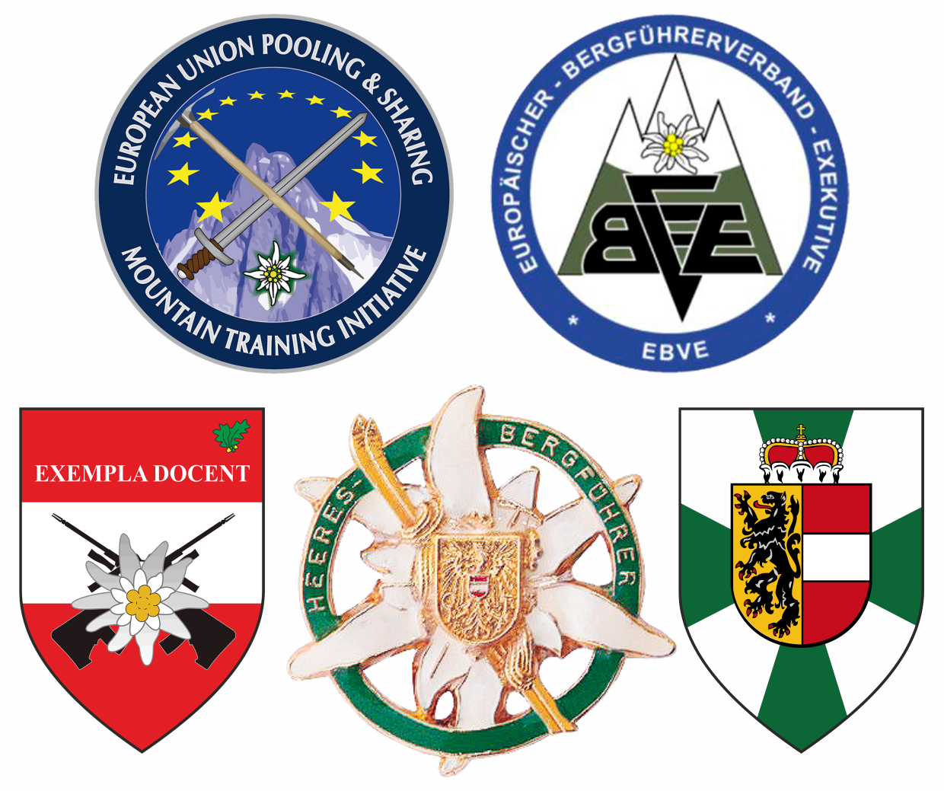

- SITUATION
The Austrian Military Climbing Championship 2025 will be hosted by the MOUNTAIN WARFARE CENTER SAALFELDEN from 12 11 25 – 14 11 25 in SAALFELDEN/SALZBURG as a part of the P&S Mountain Training Initiative.

- MISSION
The MOUNTAIN WARFARE CENTER SAALFELDEN is going to host the Austrian Military Climbing Championship 2025 in SAALFELDEN/SALZBURG. Foreign nations/partners in the MTI-Community and members of the Europäischer Bergführerverband Exekutive (EBVE) are kindly invited to take part in this event.

- EXECUTION

3.1 Personnel in charge
Overall coordinator: Col HAMMERLE Gilbert
Competition leader: LtCol STEGER-JUD Christian
Technical director: LtCol MISCHITZ Herbert
Organization manager: LtCol TASSENBACHER Wilfried
Route setter: provided by Climbing Center SAALFELDEN
Evaluation: Armed Forces Sports Centre

Location:
Competition Office / In-processing Cell (help desk)

ANTON WALLNER - Barracks
Ramseiderstrasse
5760 SAALFELDEN
SALZBURG
AUSTRIA

Climbing centre
Kletterhalle Saalfelden „FELSENFEST“
Leogangerstrasse 30 a
A-5760 SAALFELDEN
+43 664 123 8985
Mail: office@felsenfest.cc
Web: www.felsenfest.cc

3.2 Sequence of events
Time table:
Wed, 12.11.25 | Arrival of team leaders NLT 0900 hrs;  Report to competition office; administration; assignment of accommodation;  1000hrs:  Team leader meeting  Arrival of teams NLT 1200 hrs;  1300hrs-1800hrs:  training  Possibility to train and to determine the qualification routes (3 routes for each climber have to be reported to the technical director until 1800hrs)  transport back to accommodation | Competition Office  In-processing Cell: operational from 0900hrs;  WALLNER-barracks  Building 005  Lecture room 3  WALLNER-barracks  Building 005  Lectureroom 2  WALLNER-barracks  Lunch if needed:  1100 – 1230 hrs in dining-hall of WALLNER – barracks  Dinner 1800 -1930 hrs dining-hall of WALLNER – barracks
Thu, 13.11.25 | 0600 – 0715 hrs: breakfast  0715 - 0745 hrs:  move from accommodation to CLIMBING-Centre (use of own vehicles)  0745 - 0800hrs:  welcome address and introduction briefing  Administration, preparation for the championship  0800hrs – 1800hrs:  qualification (3 routes)  transport back to accommodation | Parking places at climbing centre  According to the directives of the technical director  Lunch:  1100 – 1300 hrs  Dinner:1800 – 1930 hrs  dining-hall

Fri, 14.11.22 | 0600 – 0715 hrs: breakfast  0715 – 0745hrs:  move from accommodation to Climbing centre(use of own vehicles)  Administration, preparation for the Championship  0800hrs – 1130hrs:  Semi-final (flash)  1200hrs-1400hrs:  Final (on-sight)  1400hrs – 1500hrs:  Team speed competition  Around 1500hrs:  Awards ceremony; farewell; for parts transport back to accommodation | Parking places at climbing centre  For transportation requests see paragraph 4  According to the directives of the technical director  Lunch:  1100 – 1230 hrs  dining-hall
Sat, 12.11.22 | Return trip, if necessary | Competition Office / Out processing Cell:  operational from 0800hrs to 0900hrs

3.3 Coordinating instructions
- participants
If more than one competitor per Austrian province or per foreign delegation takes part, the appointment of a team leader will be mandatory. A competitor may at the same time also act as a team leader. If a province or a foreign country sends only one competitor, this person also has to take part in the team leader meetings.
- classification of competitors
Males/females: age classes 20 and 30
Senior males/females: age classes 40, 45, 50, 55 and 60
Guest male/female: age classes as well as above
Special class males/females EBVE
Team (Speed) one class
4PAX
- reports and returns
Registration form (annex A): NLT 22. sep 2025
office.mti@bmlv.gv.at

- COMBAT SERVICE SUPPORT

4.1 dress code
4.1.1 within barracks
Battle dress
4.1.2 competition
Sports suit or private climbing suit, including an (CE /UIAA-) approved climbing harness. Private climbing boots may be used.
4.1.3 documents/ID
All participants are to carry their military ID and passport with them at all times.

4.2 HNS/ÖBH
4.2.1 board
Participants choosing a military accommodation can be boarded in military barracks via HNS/ÖBH on request.
Participants choosing a civilian accommodation, can book breakfast and dinner there. They are fully self-responsible for booking and billeting.

4.2.2 accommodation
Participants choosing a civilian accommodation will be fully self-responsible for booking and billeting.
Special offer for accommodation see list of hotels according (annexB)

4.2.3 transportation
Deployment/Redeployment of personnel participating to the climbing championship is a Sending Nation (SN) responsibility.
Recommended APOD(E) is SALZBURG Airport. For rail transport, the SAALFELDEN railway Station.
Transportation will only be provided via HNS/ÖBH from SALZBURG Airport and railway station SAALFELDEN to the Competition Office / In-processing Cell of the WALLNER barracks and vice versa, as well as to the accommodation and Climbing Centre SAALFELDEN if requested.
4.2.4 medical support
Role 1 medical support will be provided free of charge by the Austrian Armed Forces (AAF).
Medical treatment provided by civilian facilities (Red Cross, hospitals) will have to be paid directly by the SN.

4.2.5 billeting of HNS/ÖBH
Food, accommodation and medical services provided by HNS/ÖBH has to be be paid cash during the in processing
- the total costs are € 140,- including accommodation for 2 nights and food for 3 days

4.3 documents/ID
All participants are to carry their military ID and passport with them at all times.

- SIGNALS
POC: S3&S6 GebKpfZ
Obstlt STEGER-JUD +43 50201 85 28300, +43 664 6226214
christian.steger-jud@bmlv.gv.at
office.mti@bmlv.gv.at

POC: WALLNER-barracks:
Help-Desk
Duty Officer: +43 50201 92 7608117

SAALFELDEN am STEINERNEN MEER, am 10.07.2025
Der Kommandant:
Obst Ing. Gilbert HAMMERLE
7 Beilagen poster_militaryclimbingchampionship2025 Registration Form list of paricipants list of hotels, nearby climbing hall barracks plan WALLNER-Kaserne city map of SAALFELDEN Salzburg_Anreise
Ergeht an:
AusbKo HTS (nachrichtlich)

