Administrative Order
for the
Austrian Military Sports
Climbing Championship 2023

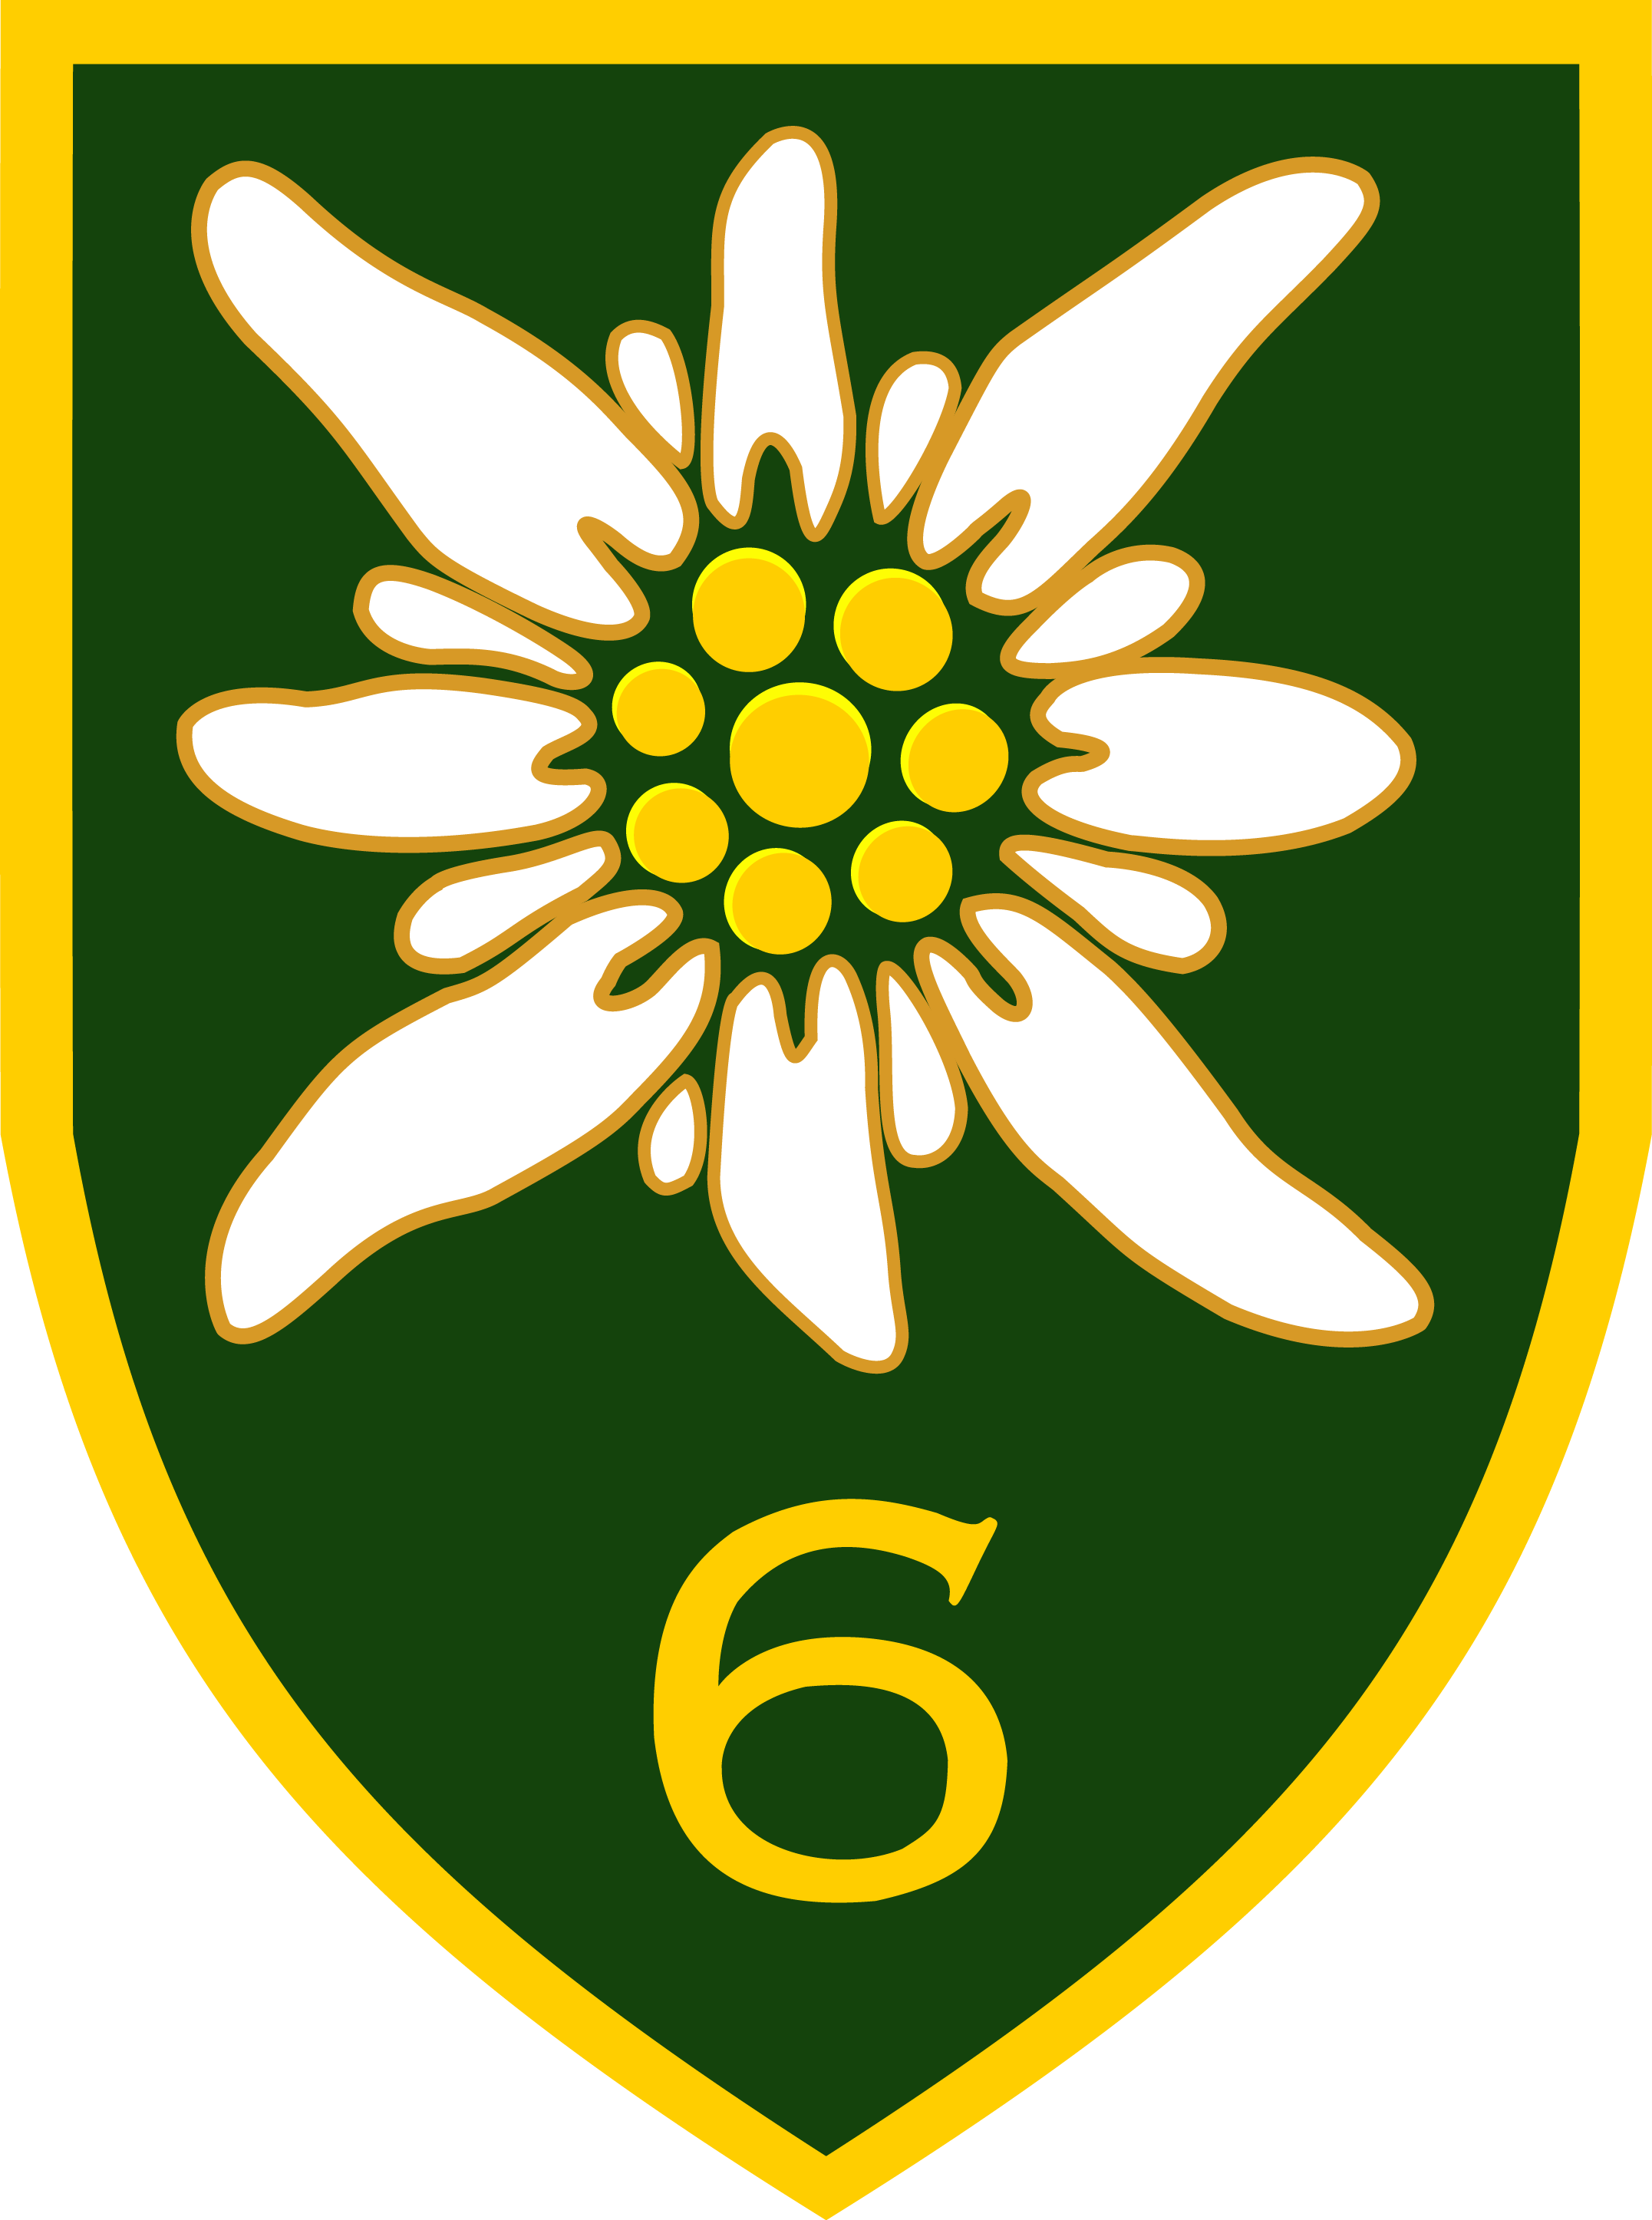

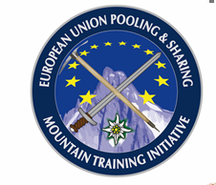

1. SITUATION 3
2. MISSION 3
3. EXECUTION 3
3.1 Personnel in charge 3
3.2 Sequence of events 3
3.3 Coordinating instructions 5
4. COMBAT SERVICE SUPPORT 6
4.1 dress code 6
4.2 HNS/AUSTRIAN ARMED FORCES(AAF) 6
5. SIGNALS 7

- SITUATION
The Austrian Military Sports Climbing Championship 2023 will be hosted by the
6th mountain brigade from 15 11 23 – 17 11 23 in WÖRGL/TIROL as a part of the P&S Mountain Training Initiative.

- MISSION
The 6th mountain brigade is going to host the Austrian Military Climbing Championship 2023 in WÖRGL/TIROL. Foreign nations/partners in the MTI-Community and members of the European Association of Law Enforcement Mountain Guides - Europäischer Bergführerverband der Exekutive (EBVE) are kindly invited to take part in this event.

- EXECUTION

3.1 Personnel in charge
Overall coordinator: Brigadier General (OF6) PFEIFER Gerhard
Competition leader: LtCol (OF4) STEGER-JUD Christian
Technical director: LtCol (OF4) MISCHITZ Herbert
Route setter: provided by Climbing Center WÖRGL
Evaluation: Armed Forces Sports Centre

Location:

Competition Office / In-processing Cell (help desk)
STANDSCHÜTZEN barracks
Kranebitter Allee 230
6020 INNSBRUCK
TIROL
AUSTRIA

Climbing centre
Kletterhalle WÖRGL
Salzburger Straße 33
A-6300 WÖRGL
Web: www.kletterhalle-woergl.at

3.2 Sequence of events
Time table:
Wed, 15.11.23 | Arrival of team leaders NLT 0945hrs;  Report to competition office; administration; assignment of accommodation;  1000hrs:  Team leader meeting  Arrival of teams NLT 1200hrs;  1300 - 1800hrs:  training  Possibility to train and to determine the qualification routes (3 routes for each climber have to be reported to the technical director until 1800hrs)  transport back to accommodation | Competition Office  In-processing Cell: operational from 0900hrs;  STANDSCHÜTZEN-barracks  CAFETERIA  STANDSCHÜTZEN-barracks  CAFETERIA  STANDSCHÜTZEN-barracks  Lunch if needed:  1100 – 1300hrs in dining-hall STANDSCHÜTZEN–barracks  Dinner 1700 -2000hrs dining-hall of STANDSCHÜTZEN–barracks or field ration
Thu, 16.11.23 | 0600hrs:  bus transport to climbing centre or with own cars  0715 - 0745hrs:  administration  0745hrs:  welcome address and introduction briefing  Administration, preparation for the championship  0815 – 1800hrs:  qualification (3 routes) and  team speed competition (4 team members)  (1st part)  1830hrs:  transport back to accommodation | Parking places at climbing centre  For transport requests see paragraph 4.2.3  According to the directives of the technical director  Lunch:  field ration  Dinner:  1930 – 2030hrs  dining-hall or field ration

Fri, 17.11.23 | 0600hrs:  bus transport to climbing center or with own cars  0730 – 1200hrs:  Semi-finals (flash)  1200 - 1330hrs:  Finals (on-sight)  1400 – 1500hrs:  Team speed competition  (2nd part)  1500 – 1700hrs:  Award ceremony and closing ceremony in the climbing center | Parking places at climbing center  For transport requests see paragraph 4.2.3  According to the directives of the technical director  Lunch:  field ration  Dinner:  field ration
Sat, 18.11.23 | Return trip, if necessary | Competition Office / Out processing cell:  operational from 0800 –  0900hrs

3.3 Coordinating instructions
- participants
If more than one competitor per delegation takes part, the appointment of a team leader is mandatory. A competitor may also act as a team leader at the same time. If a foreign country sends only one competitor, this person also has to take part in the team leader meetings.
- classification of competitors
Males/females: age classes 20 and 30
Senior males/females: age classes 40, 45, 50, 55 and 60
Guest male/female: age classes as well as above
Special class males/females Police AUT
Special class males/females EBVE
Special class males/females P&S MTI-partners
Speedclimbing (4members) one class
- reports and returns
Registration form: NLT 06 10 2023
6gebbrig@bmlv.gv.at

- COMBAT SERVICE SUPPORT

4.1 dress code
4.1.1 within barracks
Battle dress
4.1.2 competition
Sports suit or private climbing suit, including an (CE /UIAA-) approved climbing harness. Private climbing shoes may be used.
4.1.3 documents/ID
All participants are to carry their military ID and passport with them at all times.

4.2 HNS/AUSTRIAN ARMED FORCES (AAF)
4.2.1 military accommodation
Participants choosing a military accommodation will be housed in military barracks and will be provided with military food via HNS/AAF on request.

    - civilian accommodation
Participants choosing a civilian accommodation will be fully self-responsible for booking and billeting.
4.2.3 transport
Deployment/Redeployment of personnel participating in the climbing championships is a Sending Nation responsibility.
Recommended APOD is INNSBRUCK Airport. For rail transport, INNSBRUCK Central Railway Station.
HNS/AAF will provide transportation from INNSBRUCK Airport and INNSBRUCK Central Railway Station to the Competition Office / In-processing Cell of the STANDSCHÜTZEN barracks and back, as well as to the accommodation and Climbing centre WÖRGL if requested.

4.2.4 medical support
Role 1 medical support will be provided free of charge by the Austrian Armed Forces (AAF).
Medical treatment provided by civilian facilities (Red Cross, hospitals) will have to be paid directly by the SN.

4.2.5 costs
Accomodation, transport and food can be provided by HNS/AAF.
  - accommodation/night 14,10 €
  - Food:
    - Breakfast: 4,5 €
    - Lunch: 7,5 €
    - Dinner: 7,5 €
    - Additional/day: 2 €
  - Transport:
    - Depending on mode of transport between 8,53€ - 25,7€ per person/day

- SIGNALS
POC:
Climbing championship:
6th mountain infantry brigade +43 664 622 5020
STANDSCHÜTZEN-barracks:
Duty Officer: +43 50201 61 1310

